Shop Exercise. Using DOM, Reading from XML, Array, Object declaration.
In this exercise you will experiment with using DOM properties and methods; to add HTML elements to page. You can find solutions for a some steps on our demo website.

Instructions – Object declaration, Using DOM
Please follow these steps:

- Copy the files from Moodle to your local folder.

- Open shop.html. This will be your start point. It will be a good idea to keep a copy of your work on each step (like shop_step0.html, shop_step2.html and so on)

- First you will need to declare object “product”, Create array of your object instances( products) and put them in array.

function product(productName, price, image) {
this.productName = productName;
this.price = price;
this.image = image;

}
var prod1 = new product('milk', 5, 'milk.jpg') ;
var prod2 = new product('cornflake', 10,'cornflake.jpg' ) ;
var prod3 = new product('soda', 2, 'soda.jpg') ;
var prod4 = new product('bread', 8, 'bread.jpg') ;
var prod5 = new product('butter', 2,'butter.jpg' ) ;
var prod6 = new product('agria potatoes', 20,'agria_potatoes.jpg' ) ;
var products = [prod1, prod2, prod3, prod4, prod5, prod6];

- Next task to write function will display a list of product
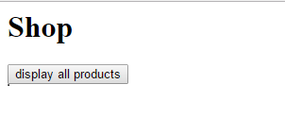
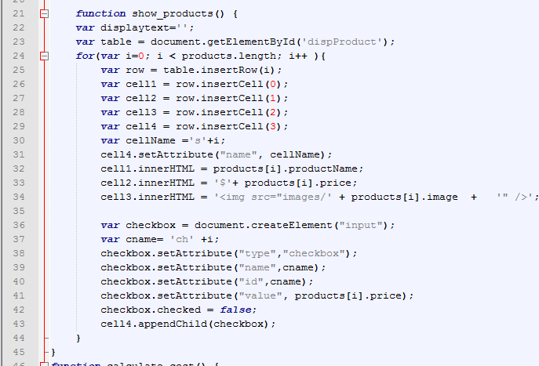
Dynamically create a table row for each product, and insert a number of cells in this row. We need to have unique name for the cell, where we add checkbox

Creating unique name and id for each checkbox
Hint: You need to make use of DOM methods and create a new checkboxes using createElement(). The attributes of the new checkbox can be set using setAttribute().

- The button implement “onclick” event and call the JavaScript function “show_products()”. Dynamic table with products will be created and displayed, when the user click button.

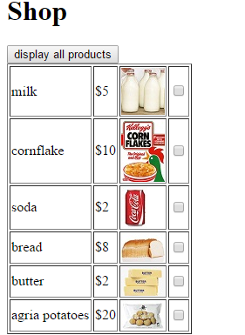
- Add button to your HTML code. This button will calculate total price for the selected products. The button implement “onclick” event and call the JavaScript function calculate_cost().

<button type="button" onclick="calculate_cost()" >Calculate Total</button>
<p id="calcost"></p>

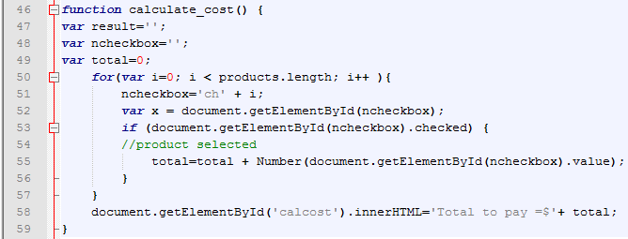
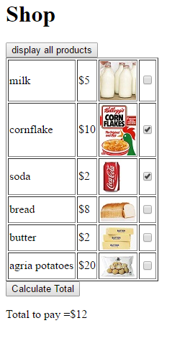
If products selected a total calculated
- The next step is to add quantity input (numeric boxes) for each product on the row.
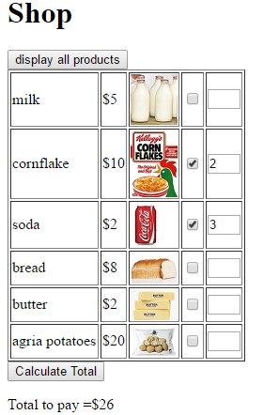
If products selected and quantity is specified, total calculated
- In function show_products() after cell4.appendChild(checkbox) add a next code. This code will add extra cell to the table row and create HTML element input and set all attributes for this element:
var cell5 = row.insertCell(4);
var cellName5 ='ss'+i;
cell5.setAttribute('name', cellName5); // this is for quantity
var quantityInput = document.createElement('input');
var qname= 'q' +i;
quantityInput.setAttribute('type', 'number');
quantityInput.setAttribute('name',qname);
quantityInput.setAttribute('id',qname);
quantityInput.setAttribute('style','width:35px;');
cell5.appendChild(quantityInput);

- Please modify function “calculate_cost ()”, the line , which does total calculation. Now we need to consider a quantity for each product, then we calculate a total.

total=total + Number(document.getElementById(ncheckbox).value) * Number(document.getElementById(qinput).value);

- Next step is to add a nice feature, if user check a checkbox – quantity box should set to 1, if checkbox has been “uncheck” the quantity should reset to 0. In function show_products() before line: cell4.appendChild(checkbox); add next code:
checkbox.setAttribute('onclick','myChange(this.value, this.name)' );

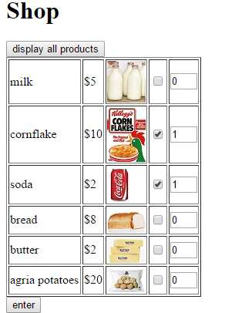
- Also we need to write code for this new function myChange

function myChange(val, qn) {
if ( document.getElementById('ch' +qn).checked)
document.getElementById('q' +qn).value=1;
else document.getElementById('q' +qn).value=0;
}

XML –input
Please follow these steps:

- Open file product.xml in the Notepad ++ . This will be a source file. From this step you will need to test your HTML file- shop using Firefox, if you are working on local computer, once you upload to server it will be OK to use other browsers.
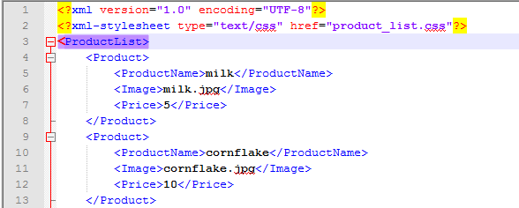
- The XMLHttpRequest object is used to exchange data with a server behind the scenes:

if (window.XMLHttpRequest) { // code for IE7+, Firefox, Chrome, Opera, Safari
xmlhttp=new XMLHttpRequest();
}
else { // code for IE6, IE5
xmlhttp=new ActiveXObject("Microsoft.XMLHTTP");
}
xmlhttp.open("GET","product_list.xml",false);
xmlhttp.send();
xmlDoc=xmlhttp.responseXML;
var x=xmlDoc.getElementsByTagName("Product");

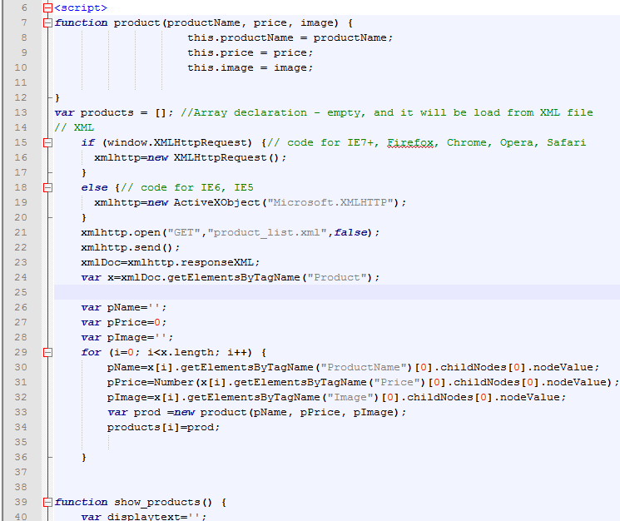
Our resource file “product_list.xml

- Task 1: modify your shop page to add next functionality, two button “+” and “-“ will allow user to adjust quantity if he/she is desired. (instead of check boxes)
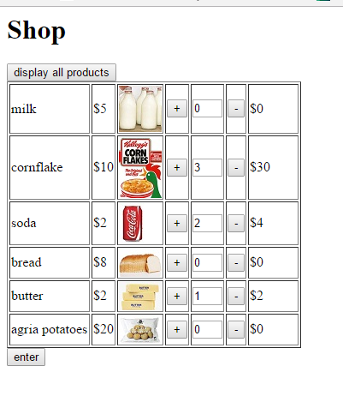

- Task 2 apply your own CSS, to make your shop page look nice

